Have a look at this map and write a complete dialogue. You are at the “X”.

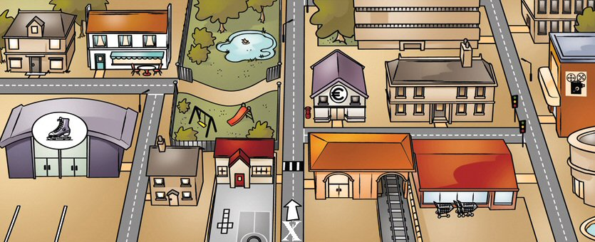

- (ask and give directions to go to the restaurant- min. 150 words)
A:
B:
A:
B:

- (ask and give directions to go to the cinema- min. 150 words)
A:
B:
A:
B:

