

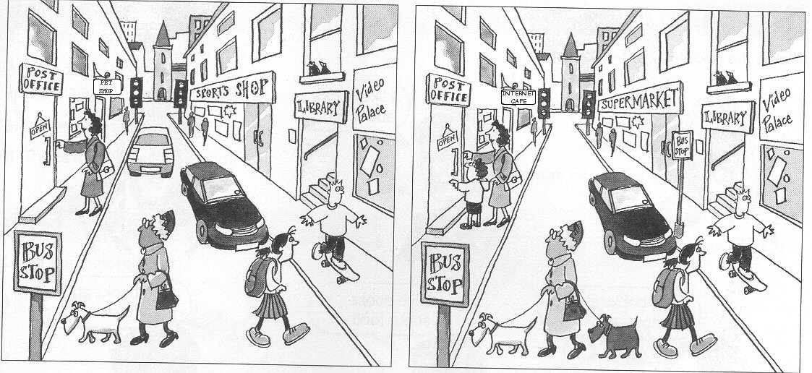
Look at the two pictures and find differences.
Write sentences using “There is / are” or “There isn`t (= is not)/ aren`t (= are not)

- In picture A,
In picture B,

Look at this map and write the directions. You are at “X”.

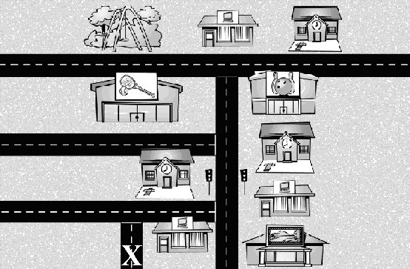

- A: Excuse me, can you tell me where the bowling alley is, please?
B: Yes.
A: Thank you very much.
B:

- A: Excuse me, is there a park near here?
B: Yes.
A:
B:

